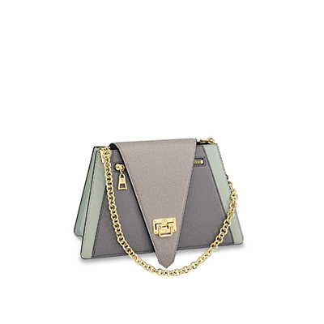

Trapeze Bag Other leathers

PRODUCT DETAILS

**- L 11 x H 7 x W 4.7 inches**

**- Gray/Light Gray/ Pistachio Green**

**- Cowhide leather**

**- Microfiber lining**

**- Gold-color hardware**

**- Chain strap ( drop : 28 cm/11 inches ) for shoulder carr y**

**- New historic trunk-inspired lock**

**- Front flat zipped pocket**